***PRACTICAL 7***

***JAVASCRIPT:2 (EVENTS AND HTML DOCUMENT OBJECT MODEL)***

1. **WRITE A JAVASCRIPT TO CREATE A BUTTON. ON CLICK ON THE BUTTON A NEW WINDOW SHOULD OPEN UP.**

<!DOCTYPE html>

<html lang="en">

<head>

    <meta charset="UTF-8">

    <meta name="viewport" content="width=device-width, initial-scale=1.0">

    <title>Document</title>

</head>

<body>

    <button class="btn" >Click me</button>

    <script>

        document.querySelector(".btn").addEventListener('click',()=>{

            window.open('https://www.google.com/','_blank','width="100" height="100"')

        })

    </script>

</body>

</html>

**OUTPUT:**

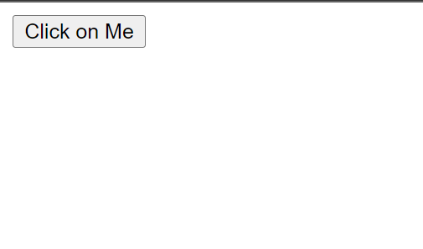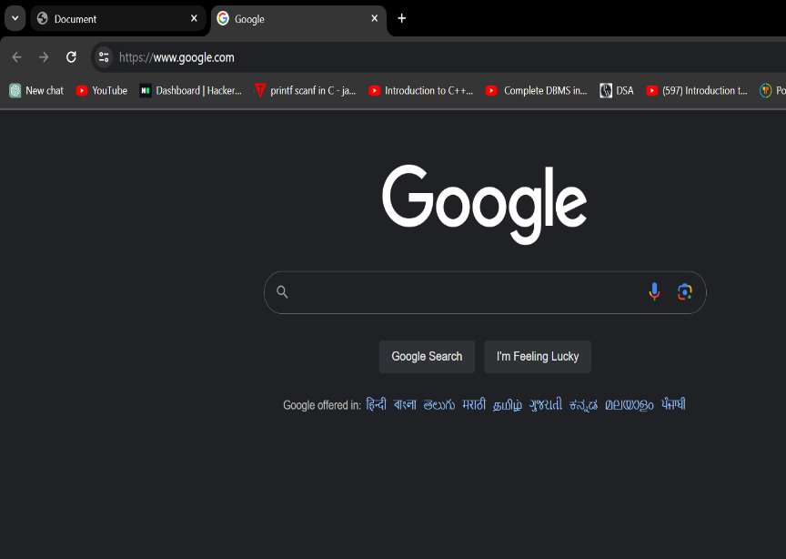

1. **WRITE A JAVASCRIPT TO GET DETAILS OF LOCATION OBJECT.**

<!DOCTYPE html>

<html lang="en">

<head>

    <meta charset="UTF-8">

    <meta name="viewport" content="width=device-width, initial-scale=1.0">

    <title>Document</title>

</head>

<body>

   <script>

    for(i in location)

    {

        document.writeln(i, " : ", location[i],"<br>");

    }

   </script>

</body>

**</html>**

**OUTPUT:**

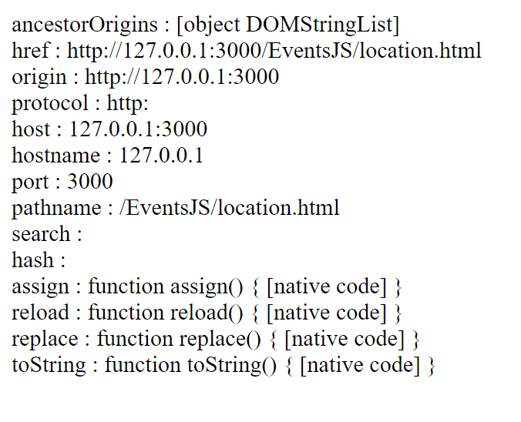

1. **WRITE A JAVASCRIPT TO GET DETAILS OF NAVIGATOR OBJECT.**

<!DOCTYPE html>

<html lang="en">

<head>

    <meta charset="UTF-8">

    <meta name="viewport" content="width=device-width, initial-scale=1.0">

    <title>Document</title>

</head>

<body>

   <script>

    for(i in navigator)

    {

        document.writeln(i, " : ", navigator[i],"<br>");

    }

   </script>

</body>

</html>

**OUTPUT:**

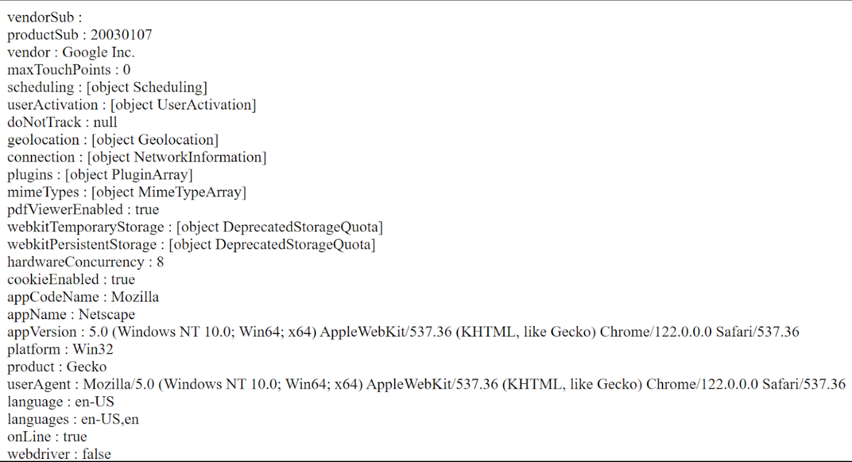

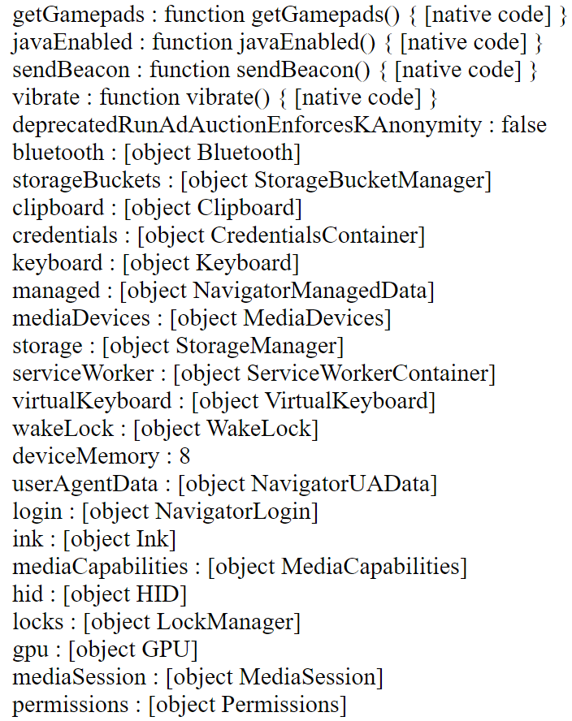

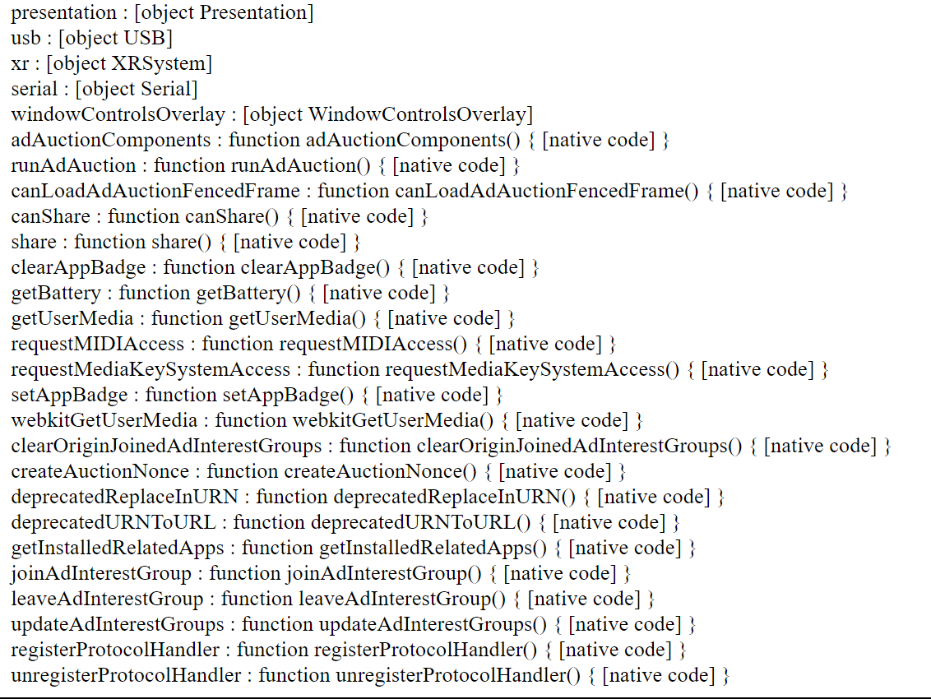

1. **WRITE A JAVASCRIPT TO RETRIEVE BROWSER NAME, ACCORDING BROWSER NAME OPEN SPECIFIC VERSION OF INDEX PAGE. I.E. CHROME_VERSION.HTML, EDGE_VERSION.HTML.**

<!DOCTYPE html>

<html lang="en">

<head>

    <meta charset="UTF-8">

    <meta name="viewport" content="width=device-width, initial-scale=1.0">

    <title>Document</title>

</head>

<body>

    <script>

        var browserName=navigator.appVersion;

        var check=browserName.appName;

        document.writeln(browserName,"<br/>",check)

    </script>

</body>

</html>

**OUTPUT:**



1. **WRITE A JAVASCRIPT TO GET DETAILS OF HISTORY OBJECT.**

<!DOCTYPE html>

<html lang="en">

<head>

    <meta charset="UTF-8">

    <meta name="viewport" content="width=device-width, initial-scale=1.0">

    <title>Document</title>

</head>

<body>

    <script>

        for(i in history)

        {

            document.writeln(i," : ",history[i],"<br>");

        }

    </script>

</body>

</html>

OUTPUT:

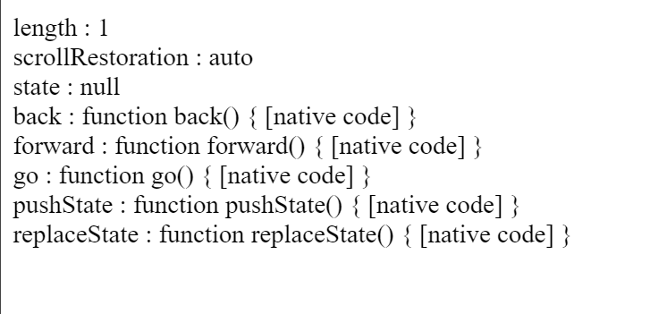

1. **WRITE A JAVASCRIPT TO WORK WITH CHANGE EVENT THAT OCCURS WHEN A DIFFERENT ITEM IN THE SELECTION LIST IS SELECTED. USE INNERHTML.**

<!DOCTYPE html>

<html lang="en">

<head>

    <meta charset="UTF-8">

    <title>Dependent Select Lists</title>

</head>

<body>

    <label for="firstList">Item: </label>

    <select id="firstList">

        <option value="monitor">Monitor</option>

        <option value="hdd">hdd</option>

    </select>

    <label for="secondList">Model: </label>

    <select id="secondList"></select>

    <script>

        const firstList = document.getElementById("firstList");

        const secondList = document.getElementById("secondList");

        firstList.addEventListener("change", function () {

            const selectedValue = firstList.value;

            secondList.innerHTML = "";

            if (selectedValue === "monitor") {

                secondList.innerHTML = `

                    <option value="acer21">Acer21</option>

                    <option value="dell22">Dell22</option>

                `;

            } else if (selectedValue === "hdd") {

                secondList.innerHTML = `

                    <option value="256gb">256gb</option>

                    <option value="512gb">512gb</option>

                    <option value="1tb">1tb</option>

                `;

            }

        });

    </script>

</body>

**</html>**

**OUTPUT:**

**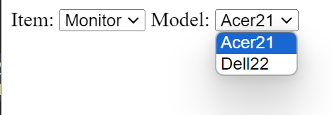    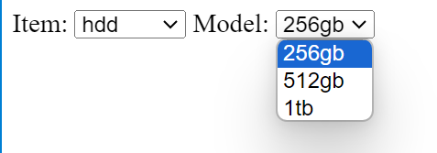**

1. **WRITE A JAVASCRIPT TO RETRIEVE MOUSE LOCATION AND DISPLAY UNICODE CHARACTER AND ITS KEY CODE ENTER FROM KEYBOARD USING EVENT OBJECT.**

<!DOCTYPE html>

<html lang="en">

<head>

    <meta charset="UTF-8">

    <meta name="viewport" content="width=device-width, initial-scale=1.0">

    <title>Mouse Location</title>

</head>

<body>

    <div>Move your mouse to see the coordinates:</div>

    <div id="mouseCoordinates"></div>

    <script>

        var mouseCoord = document.getElementById("mouseCoordinates");

        document.addEventListener("mousemove", function (event) {

            var mouseX = event.clientX;

            var mouseY = event.clientY;

            mouseCoord.textContent = "X = " + mouseX + ", Y = " + mouseY;

        });

    </script>

</body>

</html>

OUTPUT:

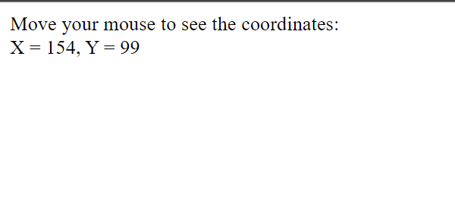

<!DOCTYPE html>

<html lang="en">

<head>

  <meta charset="UTF-8">

  <meta name="viewport" content="width=device-width, initial-scale=1.0">

  <title>Unicode Character and Key Code Display</title>

</head>

<body>

<script>

  document.addEventListener('keydown', function(event) {

    const unicodeCharacter = String.fromCharCode(event.keyCode);

    document.writeln('Unicode Character:', unicodeCharacter);

    document.writeln("<br>");

    document.writeln('Key Code:', event.keyCode);

    const outputDiv = document.getElementById('output');

    if (outputDiv) {

      outputDiv.innerHTML = `

        <p>Unicode Character: ${unicodeCharacter}</p>

        <p>Key Code: ${event.keyCode}</p>

      `;

    }

  });

</script>

<div id="output"></div>

</body>

</html>

OUTPUT:

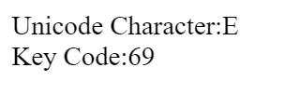    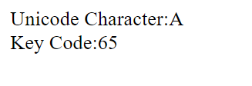

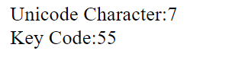    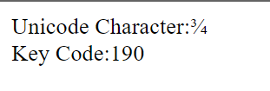

1. **WRITE A JAVASCRIPT TO VALIDATE REGISTERYOURSELF.HTML PAGE.**

**GIVE ALERT MESSAGE IF DATA IS BLANK.**

**VALIDATE EMAIL, NAME, PASSWORD, MOBILE FILED.**

<!DOCTYPE html>

<html lang="en">

<head>

    <meta charset="UTF-8">

    <meta name="viewport" content="width=device-width, initial-scale=1.0">

    <title>Document</title>

    <script>

        function checkregexp() {

            var emailId = document.getElementById("email").value;

            var nameId = document.getElementById("name").value;

            var passlId = document.getElementById("password").value;

            var mobileId = document.getElementById("mobile").value;

            var ereg = /^[a-z A-Z 0-9]+@[a-z]+\.[a-z]{2,3}$/;

            var nreg = /^[a-z A-Z]+$/;

            var preg = /^[A-Z]\w+@$/;

            var mreg = /^[6-9]\d{9}$/;

            if (!ereg.test(emailId)) {

                alert("Invalid Email");

            }

            if (!nreg.test(nameId)) {

                alert("Invalid Name");

            }

            if (!preg.test(passlId)) {

                alert("Invalid Password");

            }

            if (!mreg.test(mobileId)) {

                alert("Invalid Mobile No.");

            }

        }

    </script>

</head>

<body>

        <label for="email">Email</label>

        <input type="text" id="email"><br>

        <label for="name">Name</label>

        <input type="text" id="name"><br>

        <label for="password">Password</label>

        <input type="password" id="password"><br>

        <label for="mobile">Phone No</label>

        <input type="text" id="mobile"><br>

        <button onclick="checkregexp()">Submit</button>

</body>

</html>

**OUTPUT:**

